AUTOMATUC SOLE AND BOOT WASHER WITH MANUAL BRUSH – TYPE 29748 – CODE RC00000254
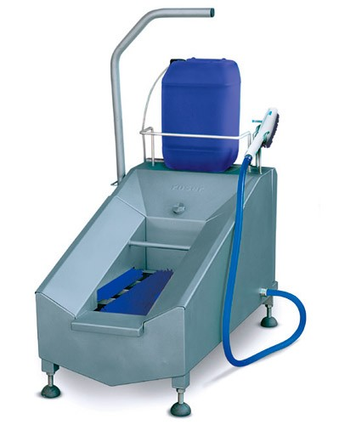
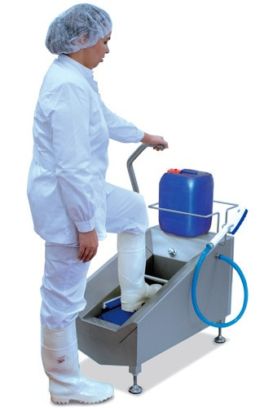
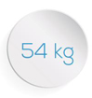
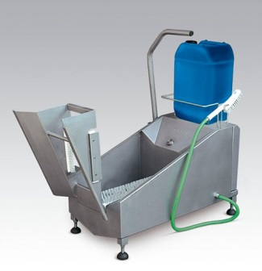
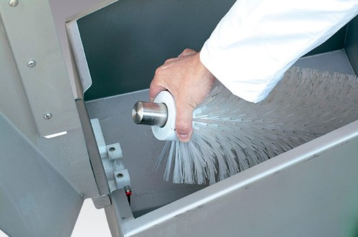
Automatic sole washer and a brush for manual cleaning of the lateral sides of the boots

Technical characteristics:
- Construction : stainless steel AISI 304
- Washing of the soles by automatic rotation of the lower brush with fluid supply, actuation by contact in the handle.
- Washing of the upper and lateral sides by means of a manual brush with a bypass valve activated by means of a push-button operation that allows the passage of water through the brush.
- Proportional water and detergent mixer, water pressure according to the network (detergent tank not included).
- Water thoroughly lost with filtration, drain 2 ”.
- A modular bottom brush of Ø200x400 mm with Ø1 mm hair (4 modules)
- Water inlet: G-1/2”
- Power: 0,37 kW
- POWER SUPPLY (standard): 400V – 50 Hz – 3Ph + N + Ground (Ask for other voltage and frequency options)

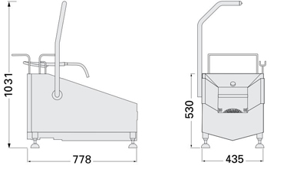
Overall dimensions:

